Web app with AI
https://learn.outsystems.com/training/journeys/agentic-development-4317/create-an-app-with-mentor-web/odc/14272
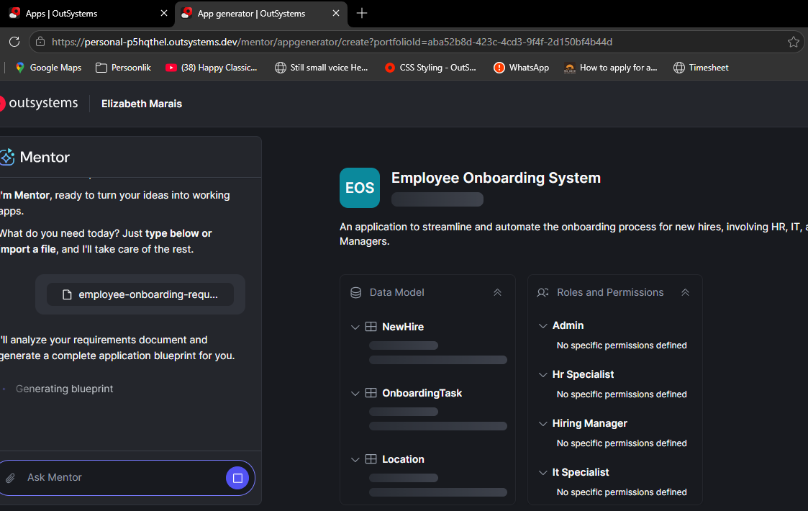
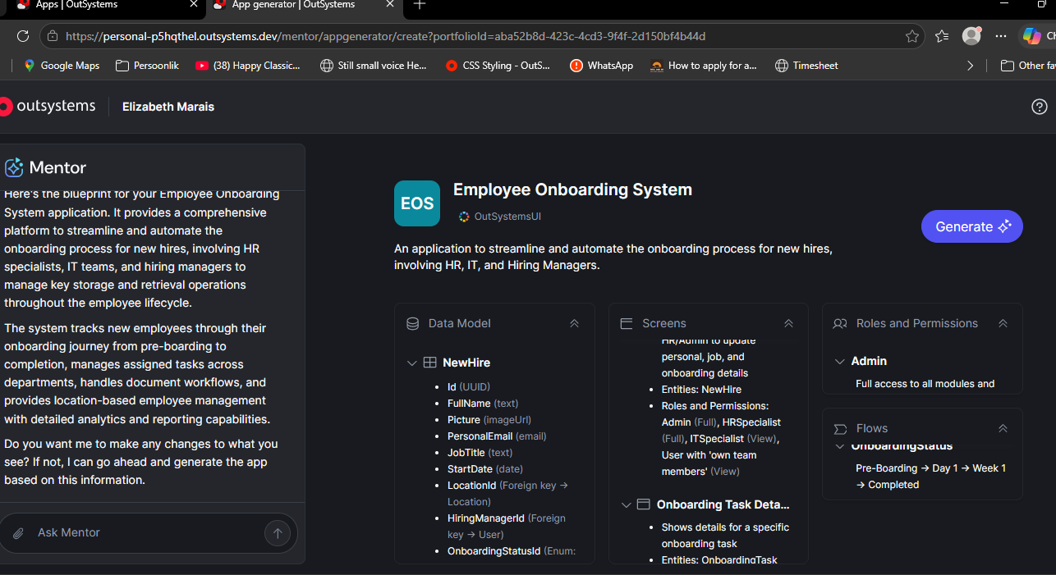
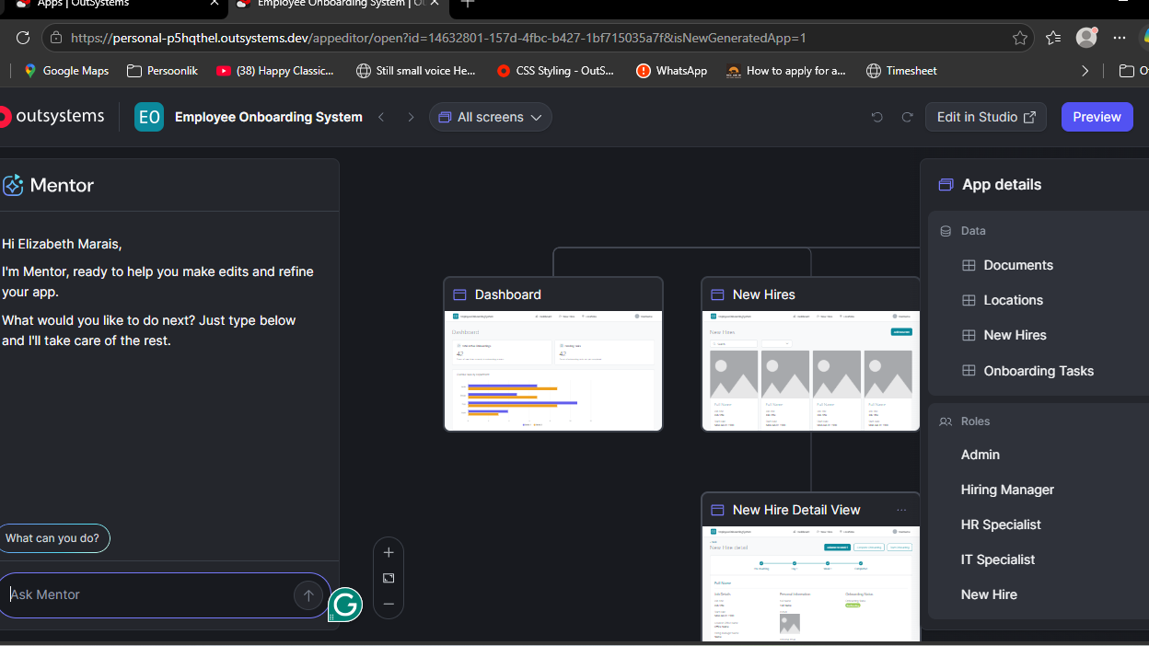
Preview
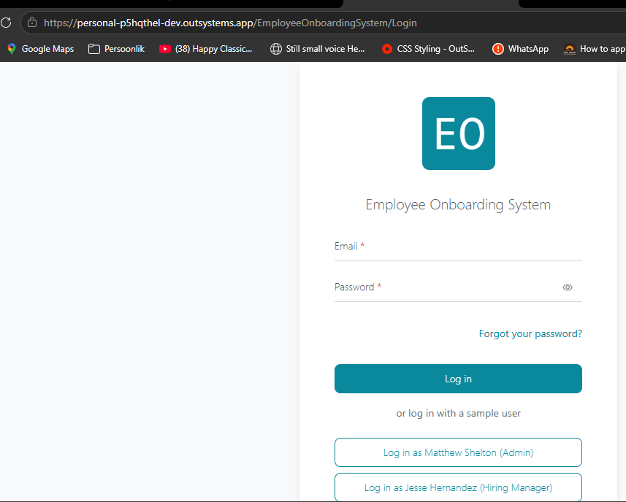

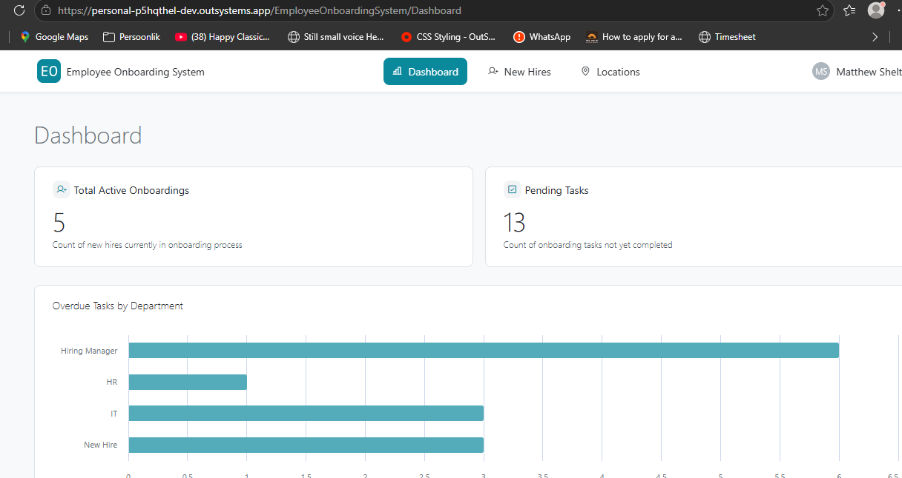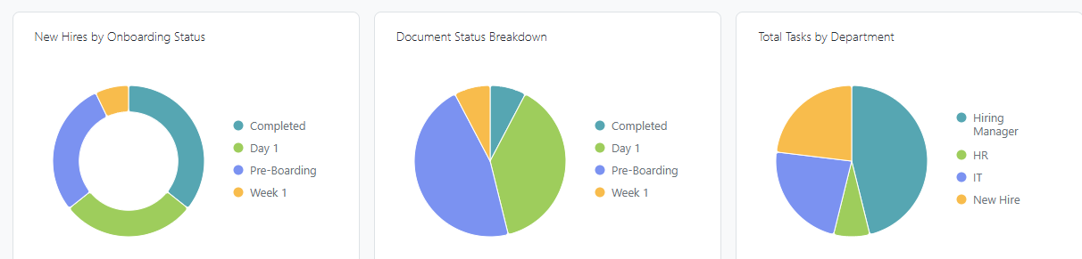

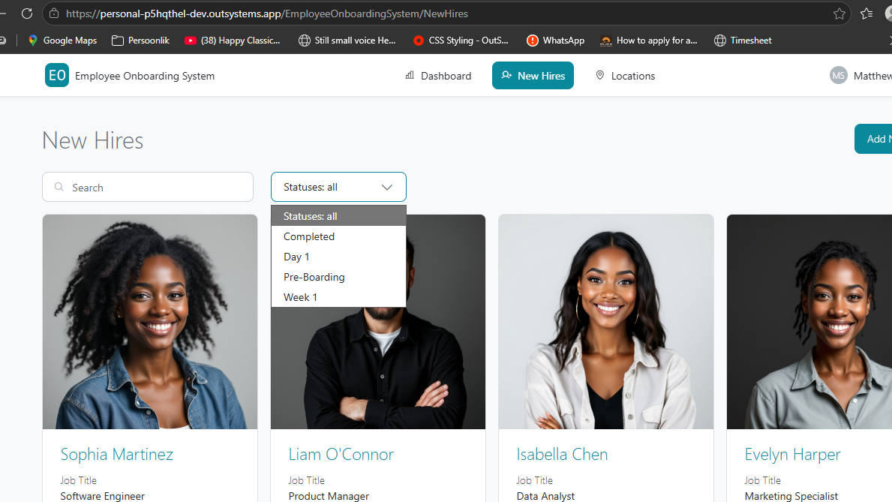
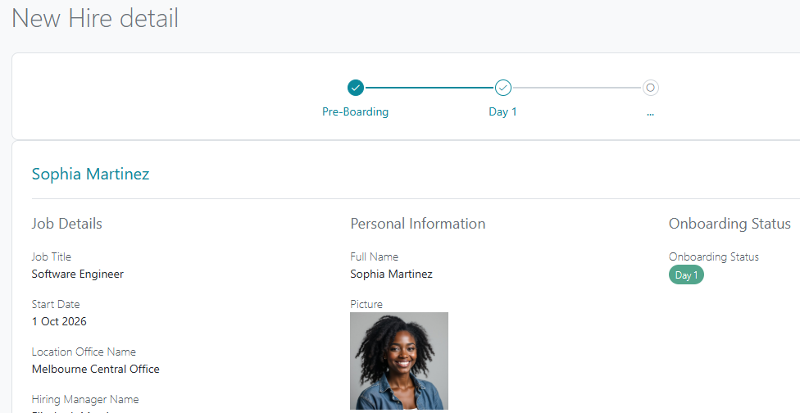

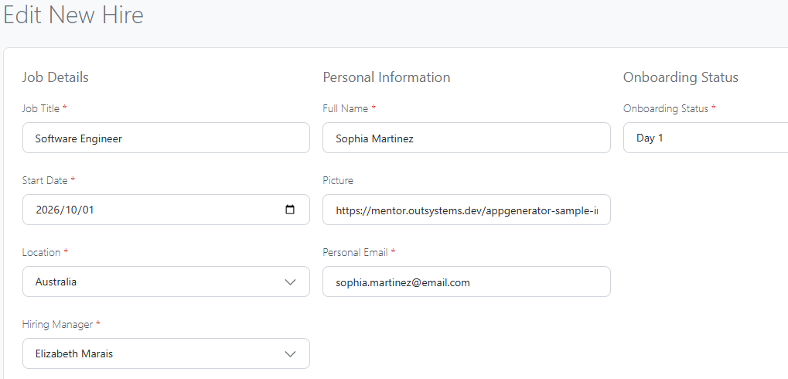

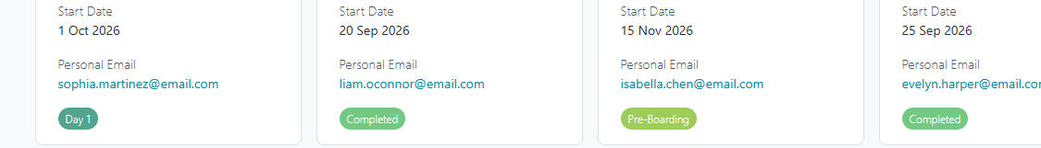

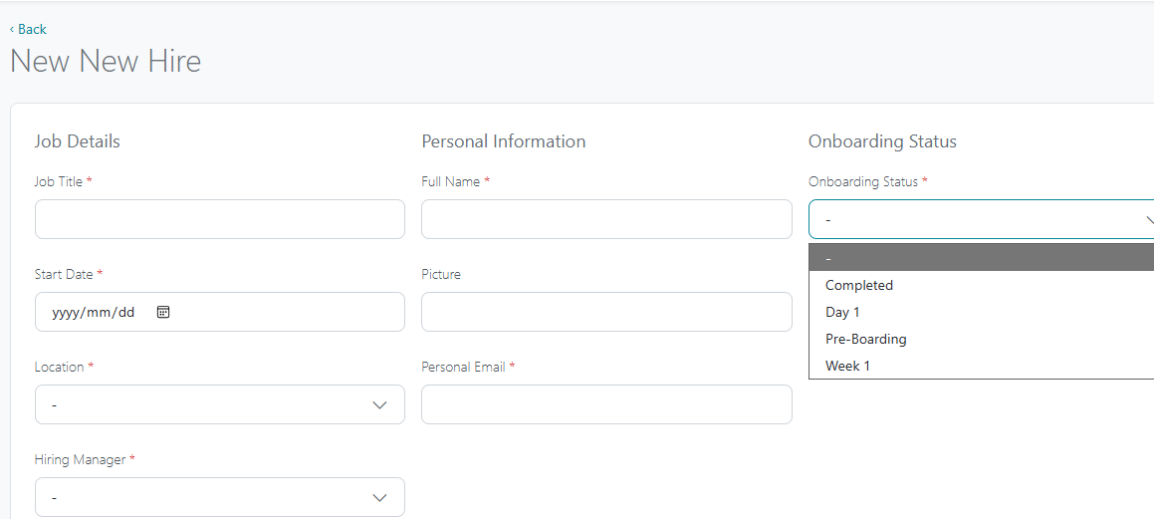
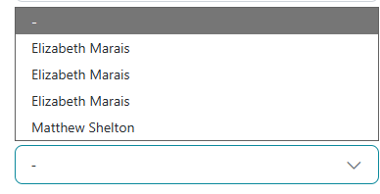
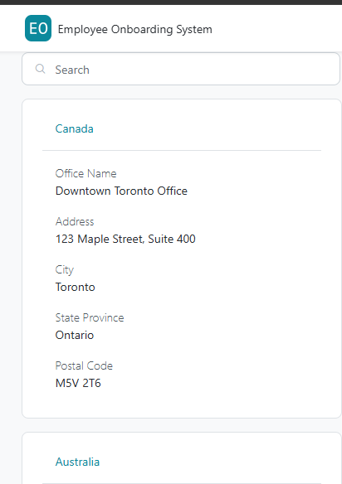

https://mentor.outsystems.dev/appgenerator-sample-images/people_men/people_men_010.jpg
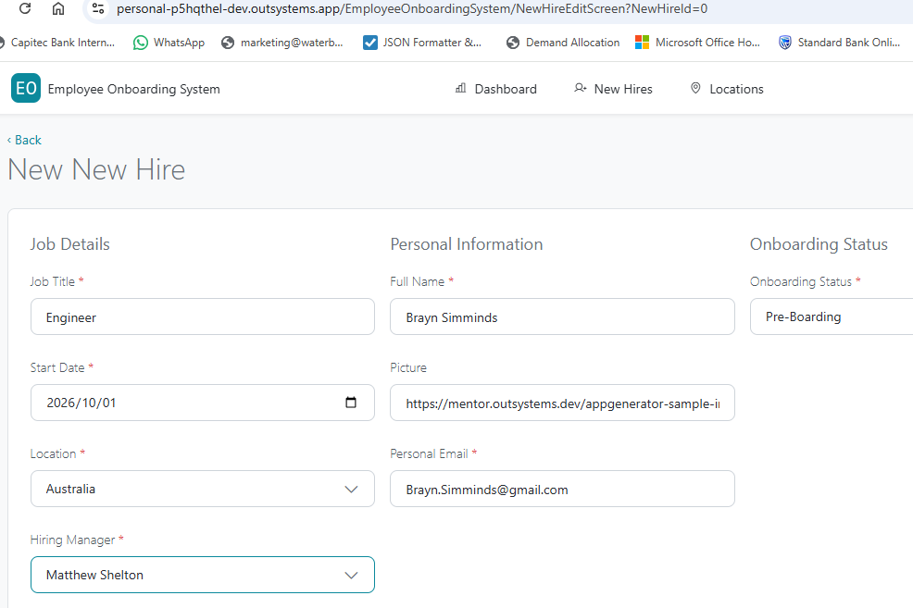

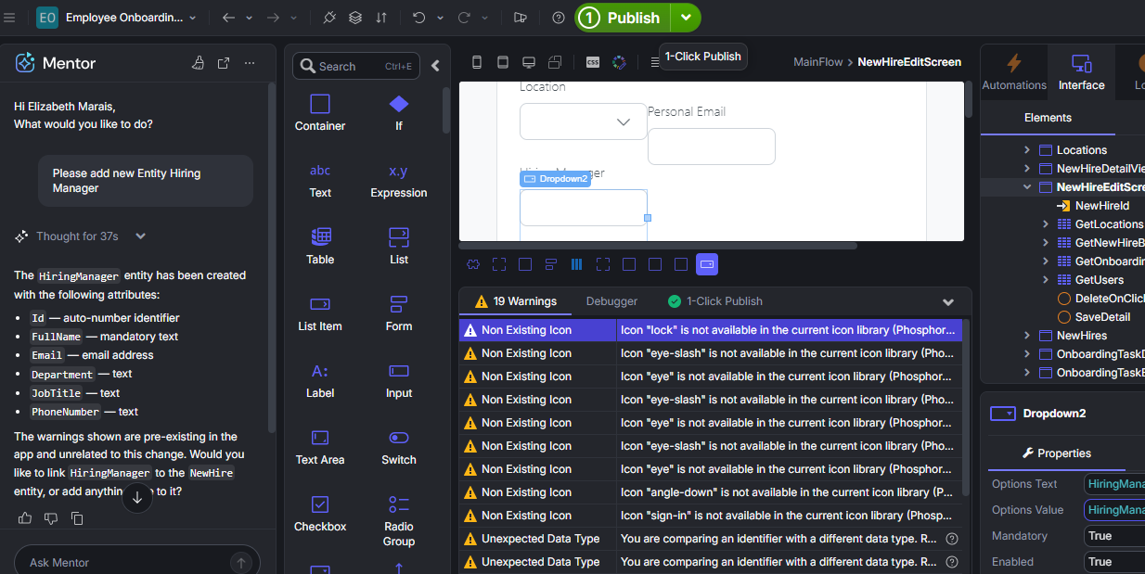
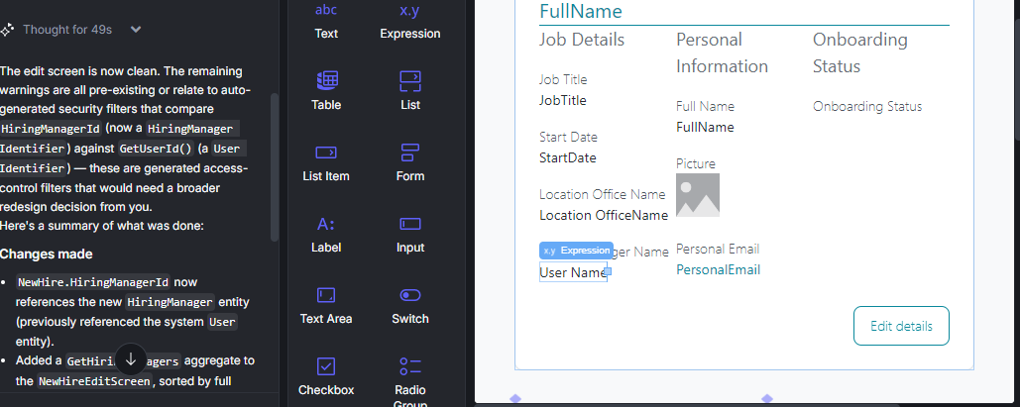
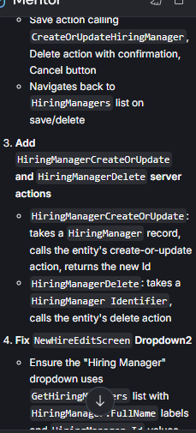

Requirement A: Track training certifications
The HR team needs to track which certifications each employee has completed during onboarding (for example, Safety Training, IT Security, Company Policies).
Write a prompt that adds this capability to the app. Consider what entities, attributes, or relationships you need.
Tip: Think about whether this is a new entity related to Employee, or an attribute on an existing entity. There's no single right answer. What matters is that your prompt is specific enough for Mentor to interpret correctly.
After Mentor applies the changes, select Publish and verify the result in the preview

Entities
Certification
Name
Add:
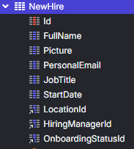
CertificationId
Requirement B: Improve the dashboard
The HR team wants to see onboarding progress at a glance: how many employees are in progress, how many completed, and a list of recent hires.
Write a prompt to add or modify a dashboard screen with this information.
Tip: If Mentor didn't produce what you expected, keep the conversation going. Write a follow-up prompt that describes what's missing or what to change. Iterating through focused prompts is a core skill.
After Mentor applies the changes, select Publish and verify the result in the preview.

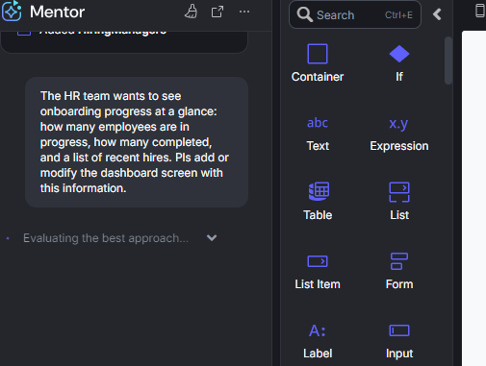
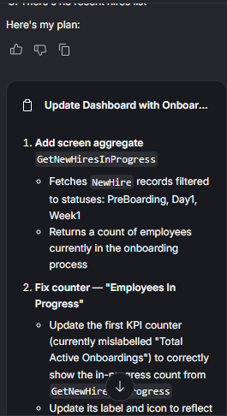

Improve display
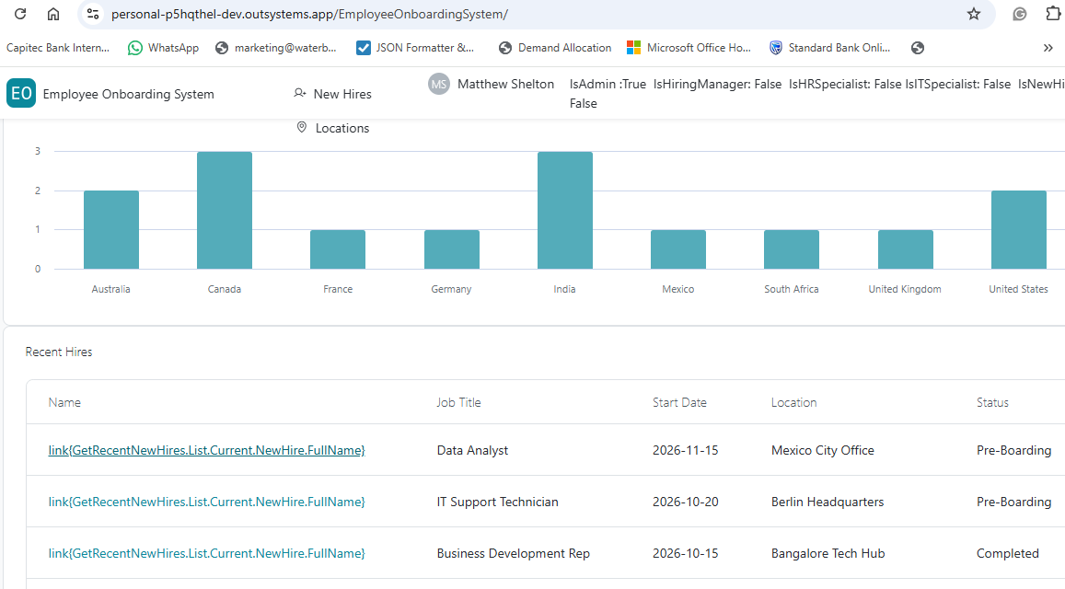
https://personal-p5hqthel-dev.outsystems.app/EmployeeOnboardingSystem/NewHireDetailView?NewHireId=3
